Brady’s Green Space Index

The distribution of green spaces in Shanghai is uneven, which significantly affects the amount of green space available to individual residents across different parts of the city.

A significant portion of Shanghai's green space is located in suburban or peri-urban areas, such as large parks, forested zones, and agricultural lands. For example, areas like the Green Ring Park in Lingang or the expansive Qingpu District feature extensive green spaces. These areas contribute heavily to the overall green space percentage but are located far from the city center, making them less accessible for daily use by the majority of the population.
In the heart of Shanghai, such as in Huangpu and Jing'an districts, green space is much more limited. These areas were developed before modern urban planning emphasized the inclusion of green spaces. As a result, the available parks and greenery are smaller and more dispersed, contributing to the lower per capita green space availability for residents in these central zones.

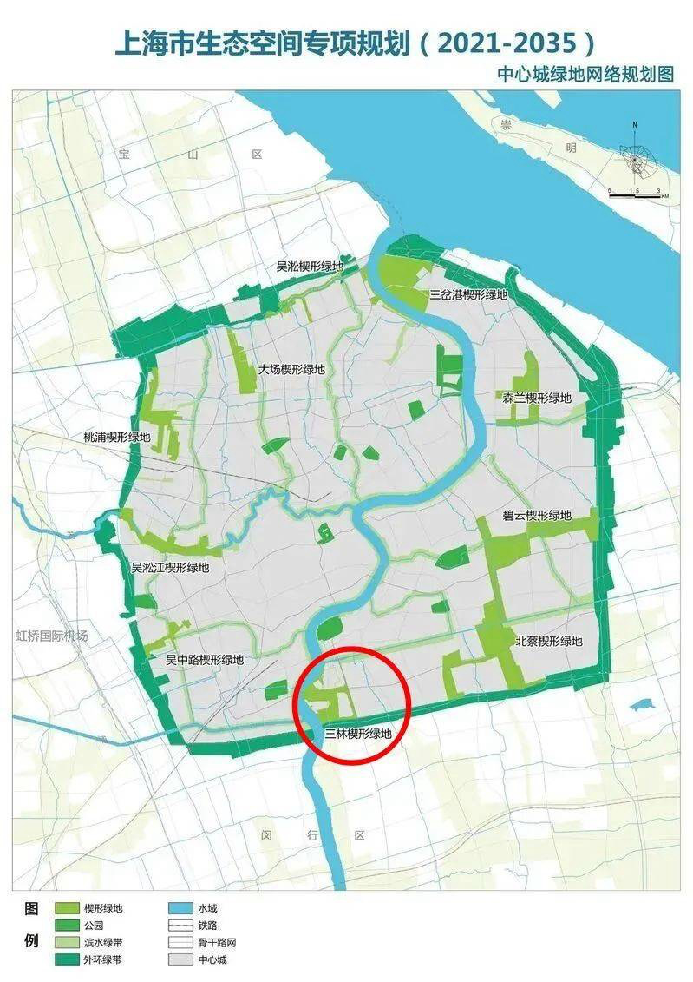

Central Shanghai is characterized by high-rise buildings, narrow streets, and densely packed residential areas, which leave little room for large parks or open green spaces. The limited space that does exist is often occupied by private gardens or small public parks that do not significantly increase the per capita green space.
The green spaces that do exist within the central urban areas are often fragmented and disconnected from one another, limiting their overall impact on improving urban livability. This fragmentation means that while a district may have a few parks, the lack of connectivity between them reduces their utility for residents who must travel to reach these spaces.
The older parts of the city were developed with little consideration for large public green spaces, reflecting the priorities of previous eras. As a result, much of the green space in central Shanghai is in the form of small, isolated parks or gardens rather than expansive public areas.

The distribution of green spaces in Shanghai is a complex issue shaped by the city's rapid growth, historical development patterns, and modern urban planning strategies. While the city as a whole might boast a significant amount of green space, the uneven distribution means that many residents, particularly those in central and older districts, have limited access to these areas on a daily basis. This disparity is a key reason why Shanghai has a relatively low per capita green space area despite its overall green coverage being quite high.

For the city-wide index, the average distance is 1.8 kilometers.
For the areas with high population density, the average distance is 3.2 kilometers.

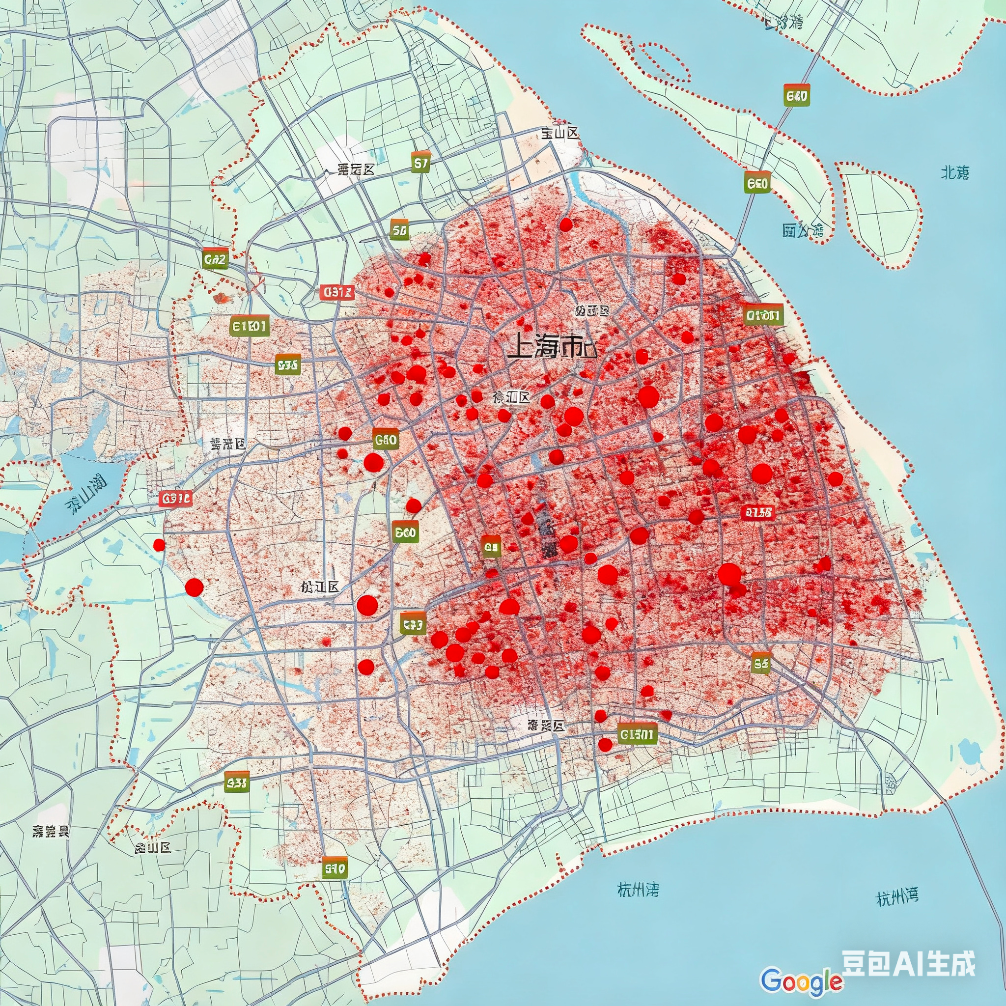
-The python code of the graph
import geopandas as gpd
import matplotlib.pyplot as plt
shanghai_boundary = gpd.read_file('path_to_shanghai_boundary.shp')
green_space = gpd.read_file('path_to_green_space.shp')
fig, ax = plt.subplots(1, 1, figsize=(10, 10))
green_space.plot(ax=ax, color='lightgreen', edgecolor='none')
shanghai_boundary.plot(ax=ax, facecolor='none', edgecolor='black', linewidth=2)
ax.set_axis_off()
plt.axis('equal')
plt.tight_layout()
plt.savefig('shanghai_green_space.png', dpi=300, bbox_inches='tight')
plt.show()

